**Week 2 Assignment 1**

**Upgrade to Windows 11**

My OS is Windows 10. I could not update it to Windows 11 since its TPM version is 1.2.

**Installing a Text Editor**

First, I downloaded the Visual Studio Code installer from <https://code.visualstudio.com/Download>.

I then installed it by following the specified instructions.

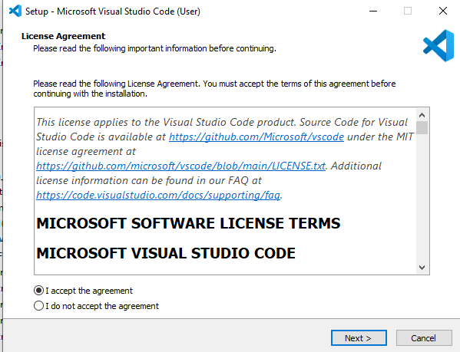

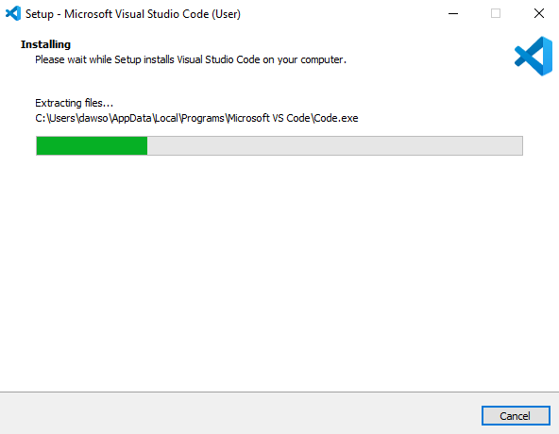

**Version Control System**

I downloaded Git, and installed it on my local machine.

Then I created a GitHub account.

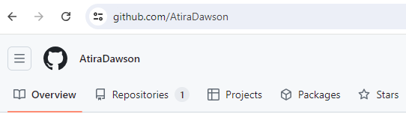

I then initialized a Git repository by running GitBash as an administrator. Then, I created a new directory known as Dawson Project using the command mkdir Daws. I then navigated to the directory using the command cd Daws. I then initialized the repository using the command git init. I navigated to local disk C where I had created my new directory, and created a text document named Dawson. I added this file to the repository using the command git add Dawson.txt. I committed this file using the command git commit -m, with the message this is my first project.

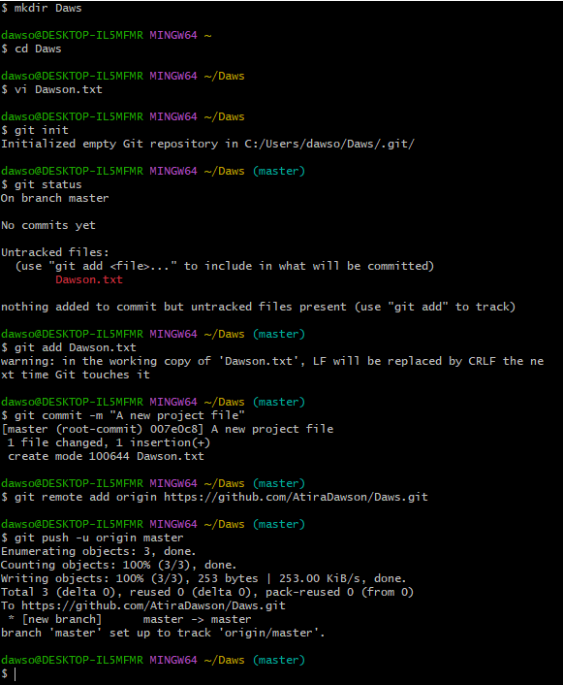

**Installation of Programming Languages**

I downloaded python version 3.12.3 from <http://wwww.python.org/>. I followed the set up procedure to install it. I the run the python code in VS Code.

**My SQL Installation**

I downloaded My SQL from <https://dev.mysql.com/downloads/windows/installer/5.7.html> and installed it by following the necessary steps.

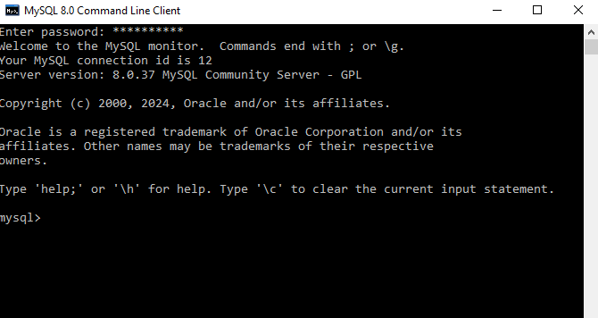

**Challenges Experienced**

I had a challenge installing Dart and Flutter. I could not install the two on my computer.